Outreach App functionality test

Add New Client:

- Select Project: No options available.
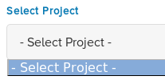
- Saving the form: Error message
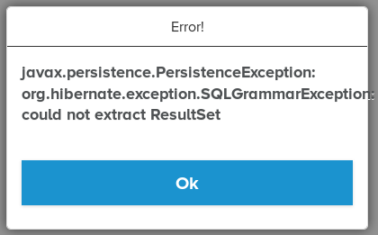
But it can be saved in database.

3.Search Client:
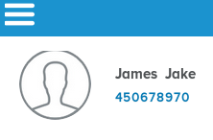
Select the client: Bad request
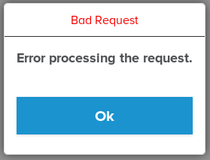

- Photo uploaded, but not shows on client search page
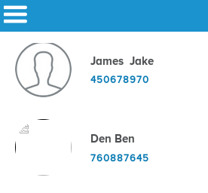
5.Sometimes all the buttons on screen don't work.

- The webpages sometimes have display error:
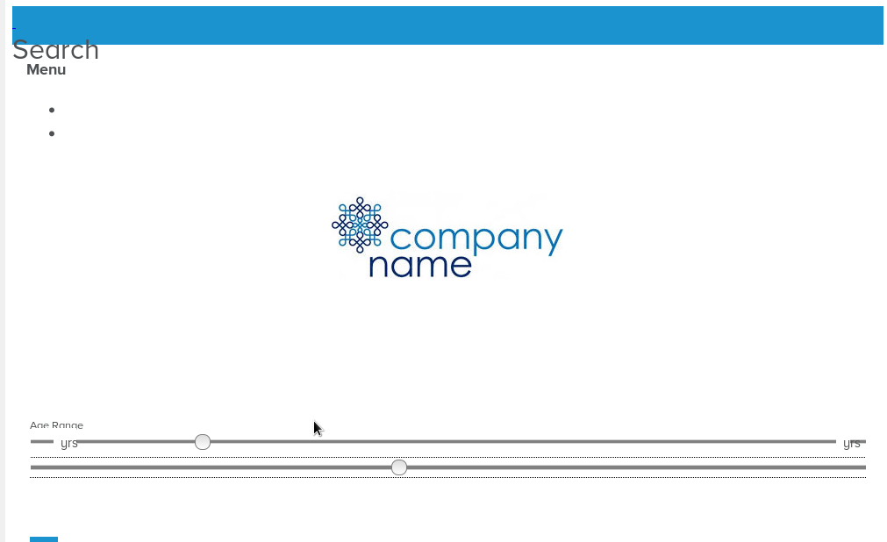
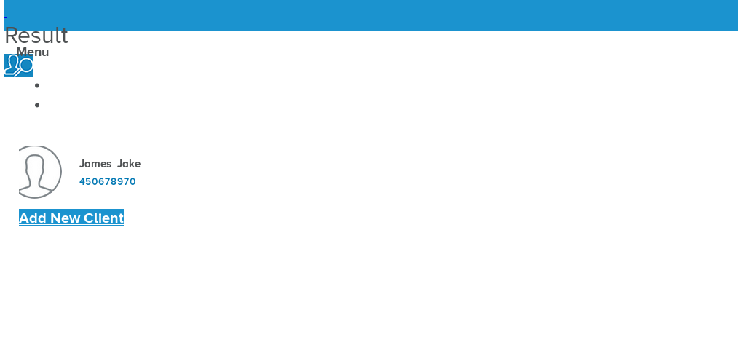

  - No “Female” option available
